Girl Under 13-Site Setup

Previous Steps: Site Registration

There are three main sections to setting up your Girl Scout’s site:
- Goal Setting: My Sales Target
- Her Cookie Story & Photo/Video upload
- Previewing and Publishing Her site


Log in to digitalcookie.girlscouts.org
To help your Girl Scout set up her business for customers, click on the “Setting Up your Digital Cookie Site” link in the Welcome section, or the “Cookie Page Setup” at the top.

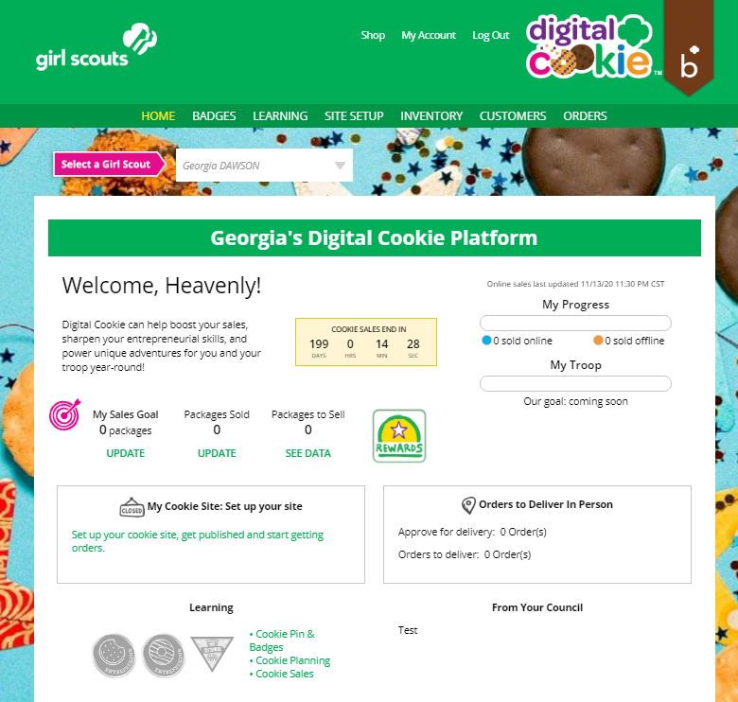


There are several different sections to her home page. Click on the headings to be taken to the instructions for that section.

- Goal Setting: “Set My Sales Target”

- “My Cookie Story”

- Photo/Video Upload

- “Preview and Publish Your Site”

Step 1>My Sales Target


1. Girls enter how many boxes of cookies they are working to sell this year through online and offline sales.
2. When the information is entered, the calculator will show how much money the troop will get from her hard work.
3. Girls can also input how many boxes she has sold in face-to-face sales to see her complete progress.
4. Clicking on “Sales Rewards” brings up a .pdf of council cookie rewards.

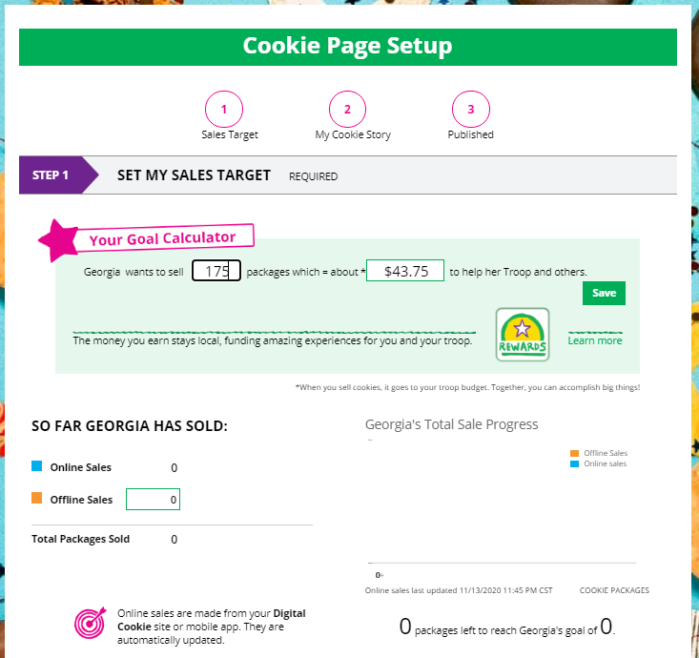
2
4
3
1
Encourage your Girl Scout to update her in-person progress regularly so she and her online customers can see how close she is to her goal.


Step 2>Her Cookie Story

  - Girls tell their customers about a troop goal and why it’s important.
  - Girls share what they’ve learned from the cookie program.
  - Save her story. She can make edits to it at any time.

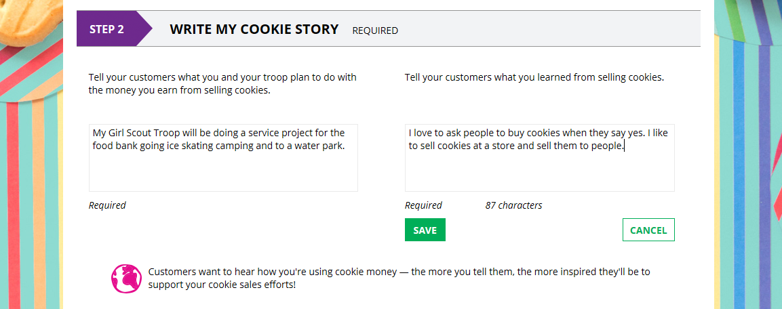
3
2
1

Step 2>Photo/Video Upload


- Girls can choose to upload a photo of themselves or use a picture from the gallery.
OR
- Girls can upload a video of themselves or use the “Cookie Boss” video.
- Bonus! Girls can get tips on how to make a great video.
Need help? You can also see the photo/video upload training for more tips.
Girls who uploaded a photo or video of themselves sold more than double the boxes on average than girls who did not.
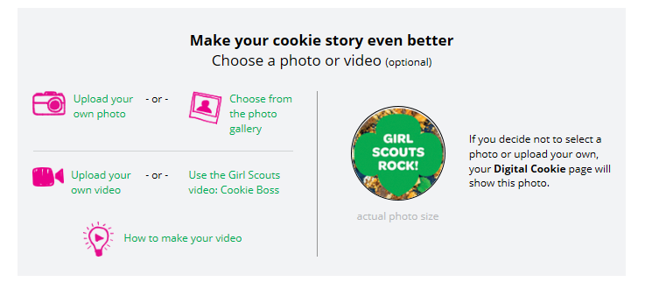
3
2
1


Step 3a>See Your Cookie Site and Publish

Almost there! Simply click the button to see how the site appears to customers and publish it.
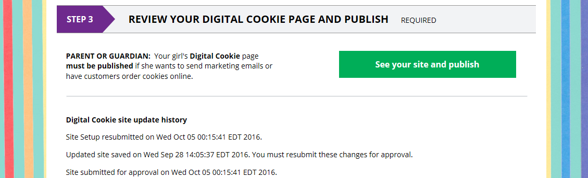
If your button only says “see your site” you may be missing some required fields, or didn’t make any changes. Go back and check that everything has been completed.


Step 3b>Preview Her Site and Approve

You will see what the customer will see. Some things to check:
- Is the spelling and grammar correct and does it tell her story?
- Make sure the photo or video are displaying correctly.
- Are the goals accurate? Do they reflect all online sales?
- If you need to change anything, click Edit and make changes, then go back to Step 6.
- If it looks good, approve and publish it.
Your Girl Scout’s cookie store now has it’s own website! If your council digital cookie sale hasn’t started, her link will not be active yet.

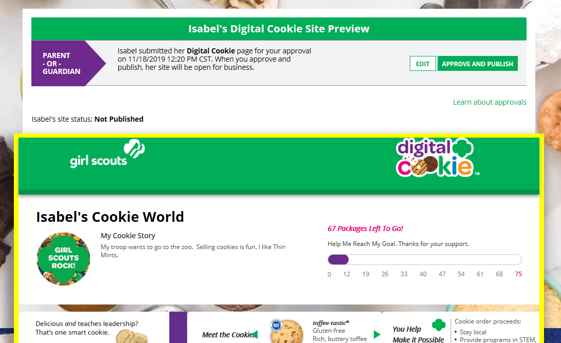

Next Steps: Marketing to Customers
Accessing the Games and Videos

